
Welcome to St John’s CE Woodland Nursery

St John’s CE Woodland Nursery School Lane Burscough Lancashire L40 4AE
Opening hours Monday to Friday 7.45am to 5.45pm, 51 weeks of the year or term time only.
Email: head@st-johns-burscough.lancs.sch.uk Website: www.stjohnsburscough.co.uk
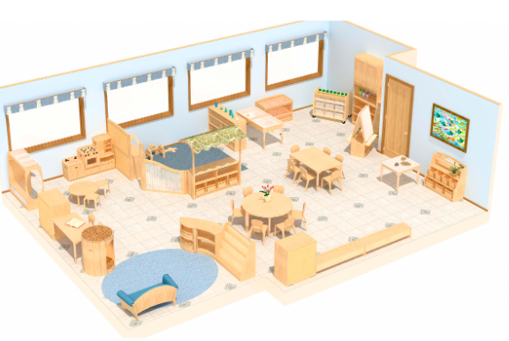

We are delighted that you are thinking of joining St John’s Woodland Nursery in September and we are excited to be welcoming you into the St. John’s Family. We combine the very best of forest school adventures with enriching indoor play.



At St John’s we create a fun, enticing, educational and inspiring learning environment that facilitates our unique curriculum whilst the children are engaged in their own personal learning journey.
At St John’s we are:
- nurturing
- supportive
- child-centred
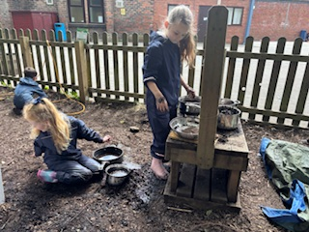
Children are encouraged to:
- pursue their interests
- ask questions
- build strong relationships
- develop a love of learning.
Children learn best and thrive when they are:
- happy
- relaxed
- taking part in what they enjoy
This fosters a genuine curiosity and love of learning that can last a lifetime.
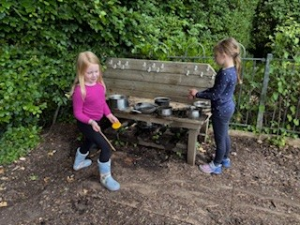



A typical day at St John’s Woodland Nursery
07:45 to 08:45 | Welcome/breakfast time/free play
08:45 to 09:00 | Morning gathering time
09:00 to 10:30 | Free flow choosing indoors and outdoors, alongside adult-led activities
10:30 to 10:45 | Milk and snack time
10:45 to 11:00 | Morning break time with St. John’s Infants
11:00 to 11:15 | Circle time
11:15 to 11:30 | Tidy up time and washing hands
11:30 to 12 noon | Lunch time in St. John’s school hall
12 noon to 12:30 | Free play
12:30 to 12:45 | Afternoon Gathering Time
12:45 to 14:15 | Free flow choosing indoors and outdoors, alongside adult-led activities
14:15 to 14:30 | Tidy up time
14:30 to 14:45 | Sensory quiet time
14:45 to 15:10 | End of the day story time for those heading home
15:30 to 16:00 | “Picky Tea” time
16:00 to 17:00 | Free play
17:00 to 17:15 | Home time story
17:15 to 17:45 | Sensory quiet time and goodbyes after a busy day.

The Curriculum
At St John’s we provide:
- an exciting curriculum packed full of open-ended questions and inspiring experiences.
- a curriculum that is responsive to the needs and abilities of every child.
- learning based on the choices of the children, their individual learning needs along and our aspirations of what they can achieve.

The children are the curriculum, and we view them as capable learners who are encouraged to take the lead in their learning.
Our Nursery is led by an EYFS qualified teacher alongside Level 3 Early Years practitioners.
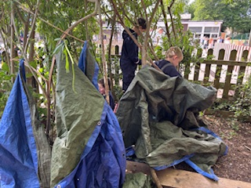

The Indoor Environment
Inside, the children will have access to three separate areas:
- Hall (or messy play zone),
- Snug (a smaller, cosier room)
- Pantry (for some brilliant baking activities!)

We want to create a home-from-home environment, where children feel safe and valued.

During free flow choosing time, the children will be exploring the continuous provision. This is an essential part of the Nursery day, and it is time devoted to the children becoming engrossed in their own personal investigations.
We offer a wealth of opportunities that spark children’s imaginations enabling them to explore and invent. We embrace children’s natural instincts to be curious and inventive.
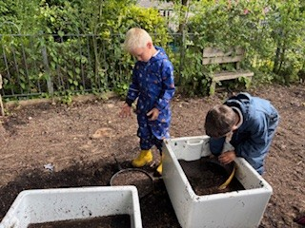
The Outdoor Woodland Environment
We have a beautiful, expansive forest school at our disposal; a natural environment for young adventurers to explore!
Nature is the best playground there is! From den and obstacle course building to toasting marshmallow and making mud pies, the forest school fuels curiosity and creativity!

We understand that choosing a Nursery setting that is right for you child is incredibly important. Through this welcome pack we have aimed to answer as many questions as possible.
However, should you have any further questions, please don’t hesitate to contact the St. John’s school office where someone will be more than happy to help.


